**DEPARTMENT OF ELECTRONICS AND INSTRUMENTATION ENGINEERING**



**VIRTUAL INSTRUMENTATION PROJECT**

**TOPIC: WATER QUALITY MONITORING USING LABVIEW AND MACHINE LEARNING**

**MENTOR: Dr. Sudarshan Sahoo**

**Submitted by :**

**SIMRAN SAHU 17-16-033**

**ABSTRACT**

This research project looks at a novel method for monitoring drinking water parameters. The microcontroller Arduino, it's software program Arduino IDE, National Instruments software program LabVIEW are used as the basis for the system. The water available in the hostels of NIT Silchar was used to perform trials as it is used for drinking purposes. The system monitors the following water parameters: temperature, pH, conductivity, and turbidity. The system consists of microcontroller Arduino, waterproof temperature sensor DS18B20, pH sensor kit, turbidity sensor with the module, conductivity sensor, buck-boost converter, jumper wires, and breadboard. Currently, the system has almost completed proof of its concept phase. The system can monitor water parameter levels close to standard manual techniques. Data can be stored directly into an Excel sheet for storage and analysis using LabVIEW and Machine Learning respectively. The system can publish its display on a web page that can be used for monitoring using a laptop or mobile phone. Similarly, the stored data can be remotely accessed.

# Introduction

The need for effective water quality monitoring is very essential as the demand for clean water supplies increases. This would provide a useful tool in safeguarding public health and ensuring quality standards are met. An assembly of various sensors that measure various parameters of water like temperature, pH, conductivity, and turbidity have been created. For voltage regulation, a buck-boost converter has been used. The buck-boost converter supplies 9V power supply to the pH sensor by regulating voltage supply from a DC source of 12V. The data collected from the sensors is logged into a CSV or excel file using LabVIEW. The collected data is analyzed and using Machine Learning algorithms, the purity of the water sample is calculated. After that, it can be determined whether the water is drinkable or not. An ESP8266 NodeMCU Wi-Fi module has been used to send the collected data over the internet using Wi-Fi. The result is displayed on a webpage.

# Background

It is very important to achieve a good water balance for drinkable water. In order to prevent a disease outbreak, it is important to determine the quality of water. Factors such as the temperature of water, pH, conductivity, and turbidity affect the quality of water. There are many other parameters of water quality too but as preliminary stage research, we focus on four parameters only. Hence, the data sets of the four parameters have been collected from an established site like Kaggle.

The following table shows the range of the measured parameters :

**|**

**Table 1: List of water parameters**

|  |  |
| --- | --- |
| **Parameter** | **Range** |
| Temperature | 25℃ |
| pH | 6.5-8.5 |
| Conductivity | 5–50 mS/m |
| Turbidity | <=5 NTU |

Where: NTU - Nephelometric Turbidity Unit

C - Celsius

mS/m - milli Seimen per meter

**System Testing and Monitoring**

Table 2 shows the sensor parameters including accuracy and output range. Other water parameters like the hardness of water, dissolved oxygen content, etc. can be measured using manual methods as the sensors available for their measurement is expensive. The hardness of water can be measured by EDTA and dissolved oxygen content can be measured using Winkler's method.

The measured parameters are collected in a CSV or excel file using LabVIEW. The data is then analyzed using Machine Learning algorithm. The predicted result is displayed on a web page using the ESP8266 module.

**Table 2:**

**System Monitoring Specifications**

|  |  |  |  |
| --- | --- | --- | --- |
| **Parameter** | **Sensing Method** | **Accuracy** | **Output Range** |
| Temperature | DS18B20 | +/- 0.5 ℃ | -55 to 125 ℃ |
| pH | pH sensor kit | +/- 0.01 | 0 to 14 |
| Conductivity | EC Sensor | +/- 0.01 µS | 0 to 4000 µS |
| Turbidity | Turbidity sensor module | +/- 0.1 NTU | 0 to 1000 NTU |

**Hardware:**

The figure shows the connection of various components used to measure various water parameters like temperature, pH, and turbidity:

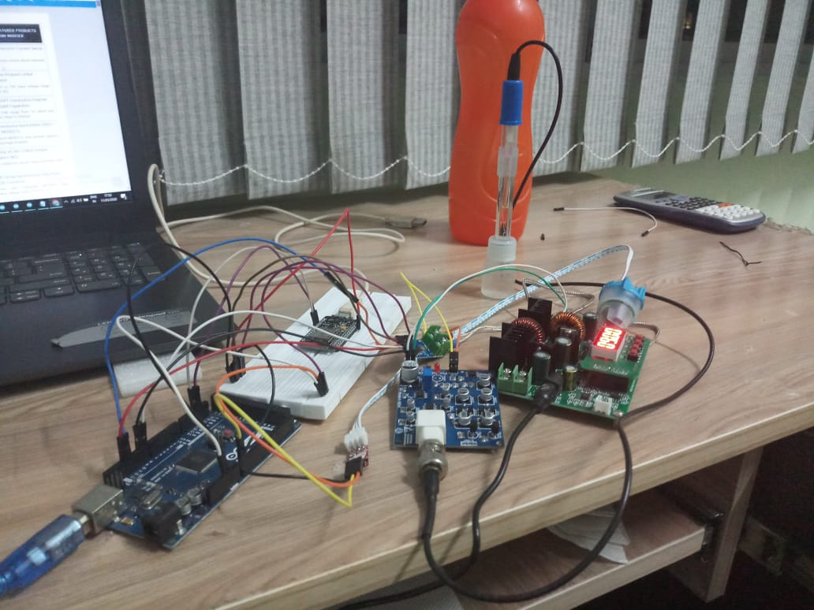

Fig 1: Hardware Implementation of the project

# 

# 

# 

# Block Diagram of the Model

The block diagram of the system is shown hereunder. It depicts the steps we follow in order to achieve the desired results. This system can also be termed as Real-Time Water Quality Monitoring as it can produce the result almost instantaneously in real-time.

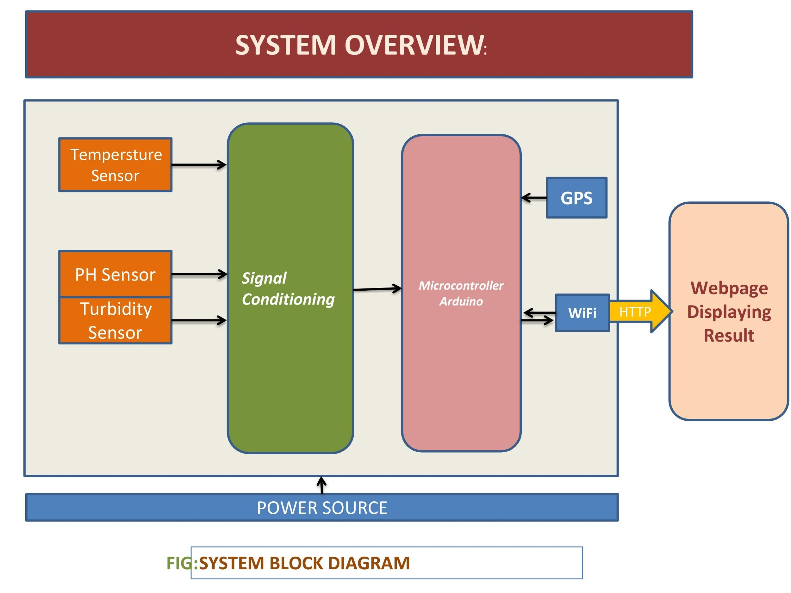

Fig 2: System Block Diagram

**IMPLEMENTATION**

The whole set up can be implemented using only LabVIEW (case structures, WHILE loop, some basic functions, and Express VI(s).

**Basic functions used:**

Greater than function, Equal to function, OR function, EXIT LabVIEW.

# LabVIEW Simulation Frontend Example

After the simulation in LabVIEW, the result shall be displayed in this way.

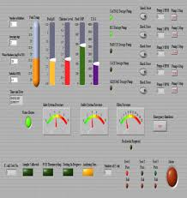

Fig 3: LabVIEW Frontend after code implementation

# 

# 

# Depiction of Real-Time Water Quality Monitoring System

After the backend analysis of the water sample, the result will be displayed in this way.

# 

# Fig: Results displayed on the website

# Future Work

At the time of submission, the test rig is nearing completion and some preliminary testing has been conducted. The conductivity sensor has not been added yet. Machine Learning algorithm is yet to be implemented. The connection with the web page has not been established yet. This will be completed as soon as possible.

# 

# 

# Conclusion and Further Improvisations

There are numerous potential applications of water quality monitoring systems. Moreover, an inexpensive system for measuring various parameters of water quality is a basic need. It can be used for environmental monitoring, wastewater treatment, and drinking water monitoring. A system like this can be implemented in the various areas of our country. It can be extensively used in the agricultural sector in order to test for acidity or alkalinity of water.

**PRECAUTIONS**

1. The input and output range of the sensors must be checked properly in the datasheet. The input voltage of each sensor should be appropriately applied.
2. The database should be created in such a way that both Machine Learning implementation and webpage display can be done at once.